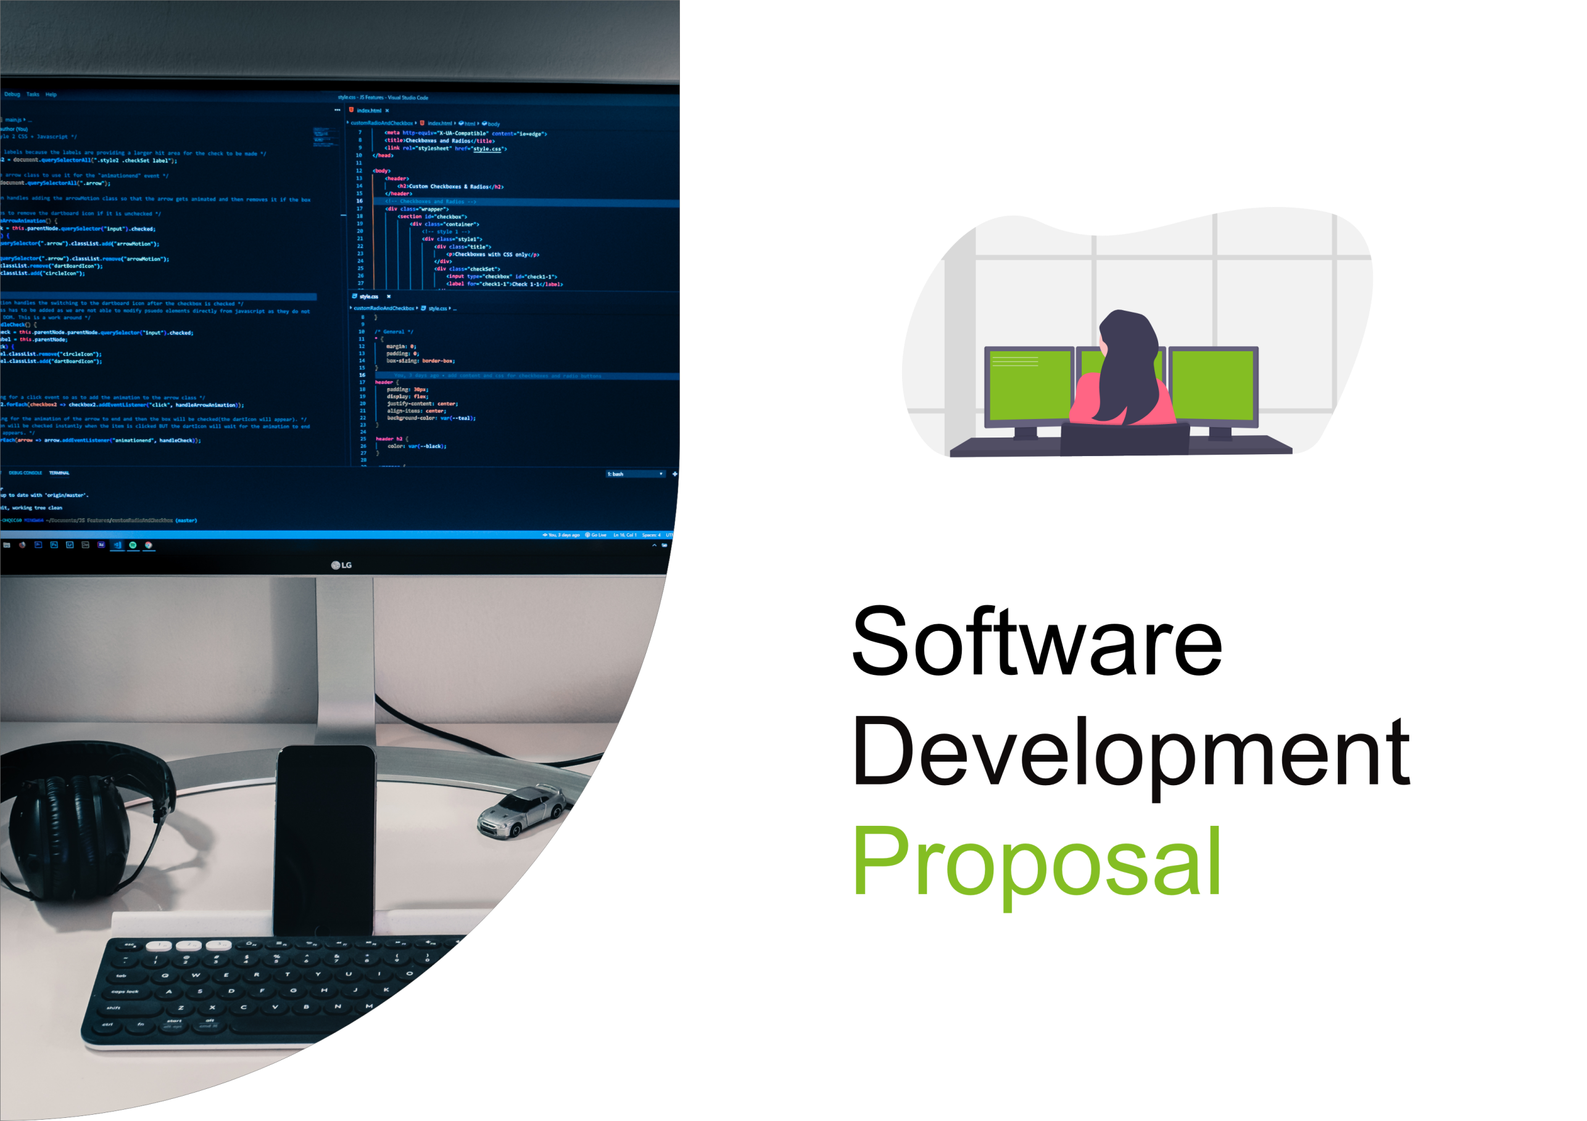
1. Overview

This proposal outlines our development plan for a real-time manufacturing status dashboard for Daikibo's four manufacturing facilities. Our team will design and implement a comprehensive monitoring solution that provides real-time visibility into the operational status of your 36 monitored machines (9 machines across each of your 4 factories). The dashboard will integrate seamlessly with your existing intranet infrastructure and internal authentication system, requiring no additional configuration from your IT team. This solution will enable your operations team to quickly identify production issues, reduce downtime, and make data-driven decisions to optimize manufacturing efficiency.
2. Scope

The Daikibo Manufacturing Dashboard will provide real-time visibility and comprehensive monitoring of all manufacturing equipment across your four facilities.
The system will consist of the following core functionalities:
Dashboard Features:
- Real-time Machine Status Display
The dashboard will display the current operational status of all 36 monitored machines (9 per factory) in real-time. Each machine will show a status indicator (operational, warning, critical, or offline) with timestamp information.

- Multi-factory Organization
Machines are grouped by factory location, allowing operators to quickly navigate between facilities. Each factory section shows an overview of all machines within that location.

- Hierarchical Expandable/Collapsible View
The interface features two levels of expandability:
- Factory level: Click to expand/collapse a factory to view all its machines
- Machine level: Click on a machine to view detailed status history and telemetry data over a configurable time period

- Machine History and Telemetry
When expanded, each machine displays:
- Historical status records with timestamps
- Key performance metrics
- Recent alerts or maintenance notifications
- Trend indicators showing performance over time

- Intranet Access Only
The dashboard is restricted to access only from within Daikibo's internal network,ensuring secure access to sensitive operational data.

- Company Authentication Integration
The dashboard integrates with your existing internal authentication server, allowing users to log in with their existing company credentials. No additional login management is required.

- Single-page Application
The entire dashboard operates on a single webpage, providing fast loading times and seamless user experience without page refreshes.
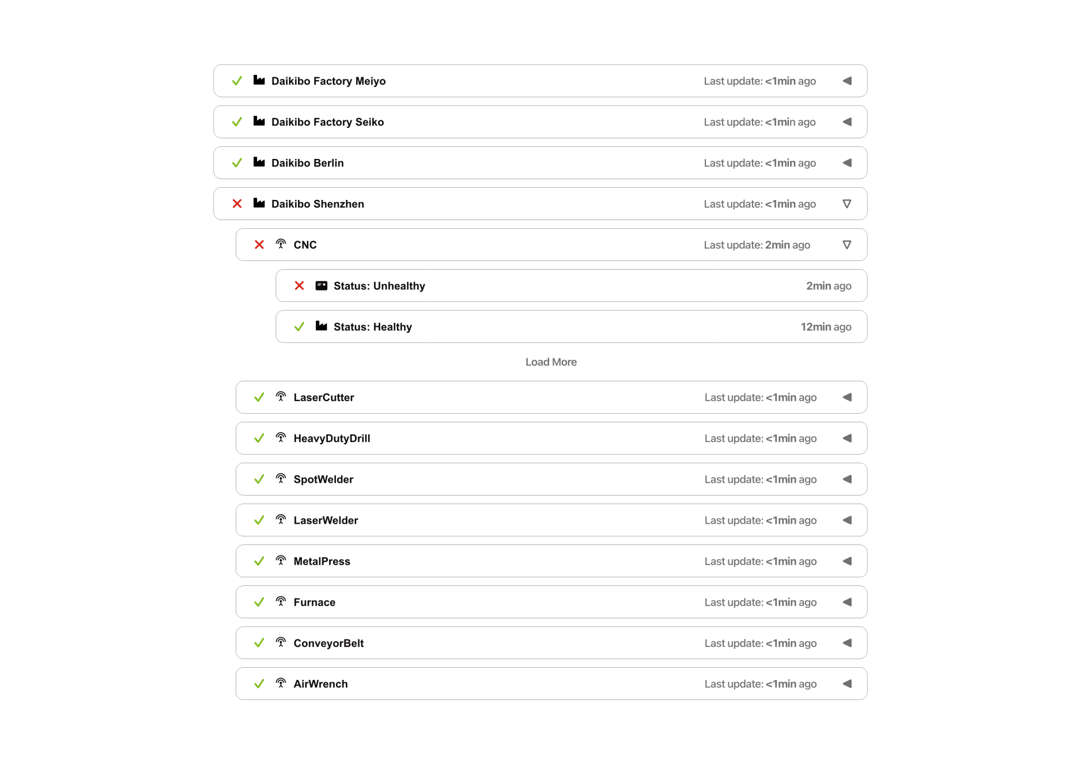
3. Estimate
Based on our analysis of the project requirements, we estimate a total of 70 man-hours of development work to complete the Daikibo Manufacturing Dashboard:
Development: 40 man-hours
• UI/UX Design and Wireframing: 8 hours
• Dashboard Layout Development: 10 hours
• Real-time Status Display Implementation: 12 hours
• Expandable/Collapsible Component Development: 6 hours
• Data Integration and API Connection: 4 hours

Testing & Quality Assurance: 20 man-hours
• Functional Testing (multiple scenarios): 10 hours
• Performance and Load Testing: 5 hours
• Bug Fixes and Refinements: 5 hours

Integration & Deployment: 10 man-hours
• Intranet Configuration Setup: 4 hours
• Authentication Server Integration: 4 hours
• Deployment and Team Training: 2 hours

TOTAL PROJECT ESTIMATE: 70 man-hours

At our standard rate of $75 per man-hour, the total project cost is $5,250.This estimate includes all development, testing, and deployment activities required to deliver a fully functional dashboard ready for production use.

4. Timeline
The Daikibo Manufacturing Dashboard project will be completed over an 8-week period with the following key milestones:

Week 1-2: Design & Planning
• September 1, 2024 - Project kickoff and requirements finalization
• September 8, 2024 - UI/UX design and wireframes completed
• Deliverable: Design mockups approved by client

Week 3-4: Development Phase
• September 15, 2024 - Development begins
• September 29, 2024 - Core dashboard features completed
• Deliverable: Working dashboard prototype

Week 5-6: Testing & Refinement
• October 6, 2024 - Quality assurance and testing begins
• October 20, 2024 - All bugs fixed and performance optimized
• Deliverable: Fully tested, production-ready code

Week 7: Integration & Deployment
• October 27, 2024 - Integration with intranet and authentication server
• November 3, 2024 - Staging environment testing and final adjustments
• Deliverable: Dashboard ready for production

Week 8: Launch & Training
• November 10, 2024 - Final client review and approval
• November 17, 2024 - Official launch to production
• November 24, 2024 - User training and support documentation delivered
• Deliverable: Live dashboard with trained users

PROJECT COMPLETION TARGET: November 24, 2024

This timeline assumes:
• Timely feedback from the client during review phases
• Availability of necessary credentials for integration testing
• No major scope changes during development

5. Support
Post-launch support and continuous product improvement are core commitments from our team. We understand that your dashboard is a critical tool for manufacturing operations, and we are dedicated to ensuring its reliability and ongoing success.
Comprehensive Support Services:
- Bug Fixes and Critical Issues
Any bugs or critical issues discovered after launch will be addressed immediately. Our development team maintains a rapid response protocol for production issues, with critical bugs fixed within 24 hours.

- Support Ticket System
We provide a dedicated support ticket system where your team can report issues, request clarifications, or ask technical questions. All tickets receive a response within 24 business hours.

- Regular Maintenance and Updates
We perform monthly maintenance to ensure optimal performance, security updates, and system stability. These updates are deployed during scheduled maintenance windows to minimize disruption.

- Feature Enhancements and New Functionality
Based on your feedback and operational needs, we can develop and integrate new features into the dashboard. Enhancement requests are prioritized and incorporated into regular update cycles.

- Performance Monitoring
We continuously monitor dashboard performance, load times, and system health. If performance degrades, our team proactively investigates and implements optimizations.

- Documentation and Training
Comprehensive user documentation and video tutorials are provided to help your team maximize the dashboard's capabilities. Additional training sessions can be scheduled as needed for new employees.

- Security and Compliance
We maintain the highest standards of security and data protection. Regular security audits are performed, and we stay current with industry best practices and compliance requirements.

- Support Commitment:
We view the Daikibo Manufacturing Dashboard as an ongoing partnership.Our team remains available to support your manufacturing operations and help optimize your facility's performance. With our continuous support and commitment to excellence, you can trust that your dashboard investment will deliver value for years to come.

